**Design database for Zen class program**

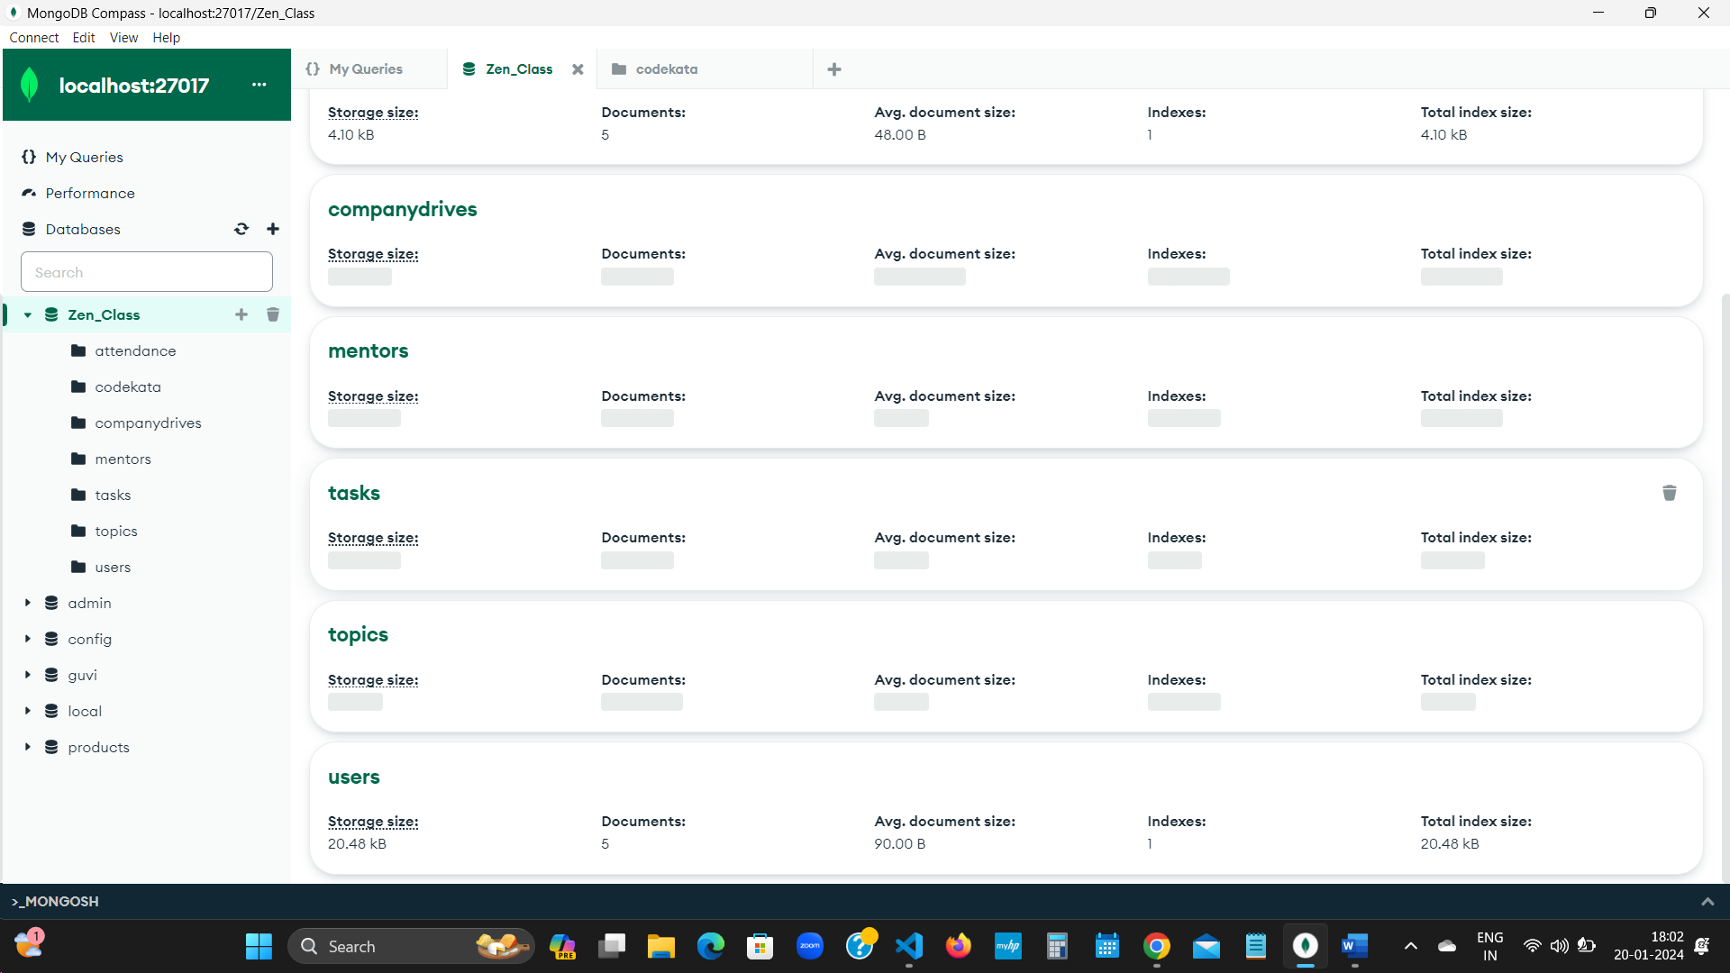

**Questions and Answers**

|  |  |
| --- | --- |
| 1. **Find all the topics and tasks which are thought in the month of October?** | |
| db.topics.aggregate([  {  $lookup: {  from: "tasks",  localField: "topicid",  foreignField: "topicid",  as: "taskinfo"  }  },  {  $match: {  $and: [  { topic_date: { $gte: new Date("2020-10-01"), $lt: new Date("2020-11-01") } }, | {  $or: [  { "taskinfo.due_date": { $gte: new Date("2020-10-01"), $lt: new Date("2020-11-01") } },  { "taskinfo.due_date": { $exists: false } }  ]  }  ]  }  },  {  $project: {  _id: 0,  topicid: 1,  topic: 1,  topic_date: 1,  tasks: "$taskinfo.task",  due_dates: "$taskinfo.due_date"  }  }  ]) |
| 1. **Find all the company drives which appeared between 15 oct-2020 and 31-oct-2020?** | 1. **Find all the company drives and students who are appeared for the placement?** |
| db.companydrives.find({  $or: [  { drive_date: { $gte: new Date("15-oct-2020") } },  { drive_date: { $lte: new Date("31-oct-2020") } }  ]  }) | db.companydrives.aggregate([  {  $lookup: {  from: "users",  localField: "userid",  foreignField: "userid",  as: "userinfo"  }  },  {  $project: {  _id: 0,  company: 1,  drive_date: 1,  students: "$userinfo"  }  } ]) |

|  |  |
| --- | --- |
| 1. **Find the number of problems solved by the user in codekata?** | |
| db.codekata.aggregate([  {  $lookup: {  from: "users",  localField: "userid",  foreignField: "userid",  as: "userinfo"  }  },  {  $group: {  _id: {  userid: "$userid",  username: "$userinfo.name"  }, | total_problems_solved: { $sum: "$problems" }  }  },  {  $project: {  _id: 0,  userid: "$_id.userid",  username: "$_id.username",  total_problems_solved: 1  }  }  ]) |

|  |  |
| --- | --- |
| 1. **Find all the mentors with who has the mentee's count more than 15?** | |
| db.users.aggregate([  {  $match: { mentorid: { $exists: true } }  },  {  $group: {  _id: "$mentorid",  mentorname: { $first: "$mentorname" },  mentee_count: { $sum: 1 }  }  }, | {  $match: { mentee_count: { $gt: 15 } }  },  {  $project: {  _id: 0,  mentorid: "$_id",  mentorname: 1,  mentee_count: 1  }  }  ]) |

|  |  |
| --- | --- |
| 1. **Find the number of users who are absent and task is not submitted between 15 oct-2020 and 31-oct-2020?** | |
| db.attendance.aggregate([  {  $lookup: {  from: "topics",  localField: "topicid",  foreignField: "topicid",  as: "topics"  }  },  {  $lookup: {  from: "tasks",  localField: "topicid",  foreignField: "topicid",  as: "tasks"  }  }, | {  $match: {  attended: false,  "tasks.submitted": false,  $and: [  { "topics.topic_date": { $gte: new Date("15-oct-2020") } },  { "topics.topic_date": { $lte: new Date("31-oct-2020") } },  { "tasks.due_date": { $gte: new Date("15-oct-2020") } },  { "tasks.due_date": { $lte: new Date("31-oct-2020") } }  ]  }  },  {$count: "No_of_students_absent"}]) |